**Project Documentation**

**Data Lake Analytics**

**1. Project Overview**

This project aims to design and implement a Data Lake Analytics solution for e-commerce transactional data using Azure Data Factory (ADF), Azure Data Lake Storage Gen2, and Azure Databricks.

The solution follows the Medallion Architecture (Bronze → Silver → Gold) to systematically ingest, clean, transform, and aggregate data into analytics-ready formats.

**2. Objectives**

* Ingest raw e-commerce data into Azure Data Lake (Bronze Layer).
* Clean, validate, and standardize data using ADF Mapping Data Flows (Silver Layer).
* Aggregate and prepare business-ready datasets (Gold Layer).
* Automate workflows with ADF pipelines and triggers.
* Enable advanced analytics and reporting through Power BI and ML models.

**3. About the Project**

E-commerce generates massive data from customers, products, orders, and payments. To extract insights, the data needs to be processed through a structured pipeline.

* Bronze Layer: Stores raw ingested data (unaltered, source of truth).
* Silver Layer: Stores cleaned and standardized data (validated, structured).
* Gold Layer: Stores aggregated, business-ready datasets for dashboards and ML.

By using this layered approach, the project ensures data quality, scalability, lineage, and business value extraction.

**4. Key Benefits**

* Centralized Storage: All raw, cleaned, and business-ready data is managed in Azure Data Lake, ensuring a single source of truth.
* Improved Data Quality: Silver layer removes duplicates, nulls, and incorrect values, making the dataset reliable for analytics.
* Business Insights: Gold layer provides aggregated insights such as total sales by country, top customers, and revenue by month, supporting decision-making.
* Customer Understanding: Enables customer segmentation (e.g., frequent buyers, high-value customers) for targeted marketing.
* Sales Optimization: Identifies best-selling products, seasonal demand, and underperforming items.
* Scalability: Handles growing e-commerce data volumes without performance issues using Azure cloud resources.
* Automation: ADF pipelines and triggers automate the ETL process, reducing manual effort and errors.
* Support for Advanced Analytics: Gold layer data can be used for predictive models like customer churn prediction or recommendation systems.
* Cost-Effectiveness: Cloud-based pay-as-you-go model reduces infrastructure and maintenance costs.
* Auditability & Lineage: Bronze → Silver → Gold layering preserves data history and transformation steps, ensuring traceability.

**5. Architecture Diagram**

**High-Level Architecture Flow:**

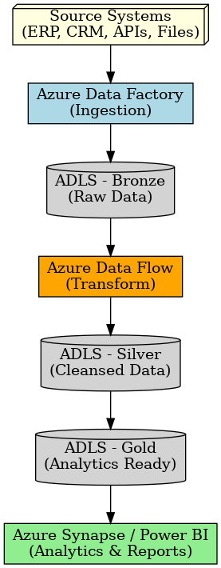

**5.1 Architecture Flow**

Data Ingestion (Bronze Layer)

* E-commerce raw data (CSV files, databases, APIs) is ingested into Azure Data Lake Storage Gen2 using Azure Data Factory (ADF) pipelines.
* Data is stored in its original format (raw, unaltered) for audit and traceability.

Data Processing & Cleaning (Silver Layer)

* Raw data from the Bronze layer is cleaned, validated, and standardized.
* This step uses ADF Mapping Data Flows and Azure Databricks notebooks to remove duplicates, handle null values, and enforce data consistency.
* The output is structured, analytics-ready data stored in the Silver layer.

Data Transformation & Aggregation (Gold Layer)

* Silver data is transformed into aggregated, business-focused datasets.
* Examples include:
  + Total sales by country
  + Monthly revenue trends
  + Customer segmentation (high-value, frequent buyers)
* These curated datasets are stored in the Gold layer for reporting and advanced analytics.

Analytics & Consumption

* Power BI connects to the Gold datasets for dashboards and interactive reporting.
* Machine Learning models (e.g., churn prediction, recommendation systems) are trained using Gold data in Azure Databricks.
* Business applications and APIs can also consume Gold data for operational insights.

Automation & Orchestration

* ADF pipelines and triggers orchestrate the entire process (Bronze → Silver → Gold).
* This ensures continuous data refresh, auditability, and minimal manual intervention.

**6. ER Diagram**

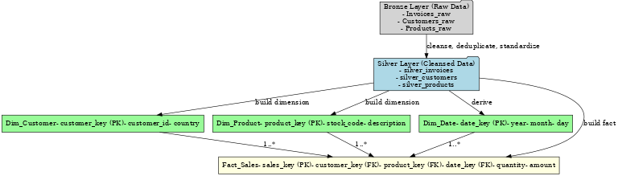

**6.1 ER Model**

* **Customers** → CustomerKey (PK), CustomerID, Country
* **Products** → ProductKey (PK), StockCode (ProductID), Description, UnitPrice
* **Orders (Invoices)** → OrderKey (PK), InvoiceNo, InvoiceDate, CustomerKey (FK)
* **OrderDetails** → OrderDetailKey (PK), OrderKey (FK), ProductKey (FK), Quantity, UnitPrice, LineTotal

**7. How it Works**

Data Sources (CSV, DB, API)

* Raw e-commerce data is collected from multiple sources such as CSV files (e.g., Kaggle dataset), databases, or APIs.
* This ensures that both structured and semi-structured data are available for downstream analytics.

Azure Data Factory (ADF)

* ADF orchestrates data ingestion pipelines.
* It automates the extraction of raw data from sources and loads it into the storage system.
* Scheduling and monitoring ensure continuous and reliable data movement.

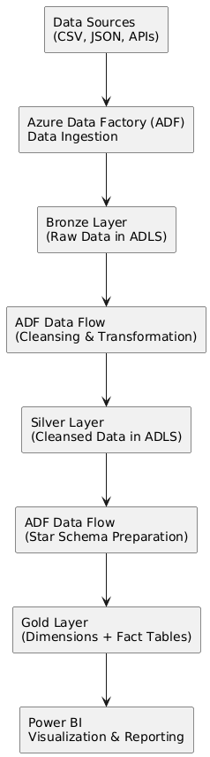

Azure Data Lake Storage (ADLS Gen2)

* The ingested data is stored in the Medallion Architecture format:
  + Bronze Layer → Raw, unprocessed data (kept for traceability).
  + Silver Layer → Cleaned, validated, and standardized data.
  + Gold Layer → Aggregated and business-ready datasets for reporting.
* This layered structure helps maintain data quality and governance.

Azure Data Lake Analytics (ADLA)

* Performs processing and querying on curated datasets.
* Enables advanced analytics and large-scale computations without needing a dedicated cluster.
* Helps prepare data models for reporting and insights.

Power BI

* Connects to the Gold Layer datasets.
* Provides interactive dashboards, reports, and KPIs for business decision-making.
* Stakeholders can track sales trends, customer behavior, and other insights in real time.

**8. Conclusion**

The Data Lake Analytics project successfully implemented a Medallion Architecture (Bronze, Silver, Gold) using Azure Data Factory (ADF), Azure Data Lake Storage (ADLS), and Power BI.

* Raw retail data was ingested into Bronze, cleansed and standardized in Silver, and aggregated into Gold for analytics.
* Automated ADF pipelines ensured reliable ingestion, transformation, and governance of data.
* Power BI dashboards delivered clear business insights, including sales trends, top products, customer analysis, and revenue growth patterns.
* The solution achieved its goals of centralizing data, improving quality, enabling decision-making, and reducing manual effort.

This project demonstrates a scalable, cost-efficient, and business-ready data platform that can be extended in the future with real-time ingestion, advanced analytics, and AI/ML use cases.